STRUCTURAL(CONSTITUTIONAL) ISOMERISM

ISOMERISM AND STRUCTURAL ISOMERISM (LEC-01) - COMPLETE JEE NOTES

INTRODUCTION TO ISOMERISM

CORE THEORY: DEFINITION AND CLASSIFICATION
Isomerism represents the relationship between compounds that have the same Molecular Formula (MF) but differ in their properties.

Isomerism is the existence of compounds with the same molecular formula but different structures or spatial arrangements of atoms.

ISOMERISM CLASSIFICATION HIERARCHY:
1. STRUCTURAL ISOMERISM (CONSTITUTIONAL):
Differences in the structural formula or connectivity of atoms.
Types :-
- Chain Isomerism (CI)
- Ring-Chain Isomerism (RCI)
- Position Isomerism (PI)
- Functional Isomerism (FI)
- Metamerism (M)
- Tautomerism (T)

2. STEREOISOMERISM:
Same connectivity (structural formula) but different arrangement of atoms in space.
Types :-
- Conformational (Rotamers)
- Configurational: {Itself has two types}
- Geometrical Isomerism (GI)
- Optical Isomerism (OI)

PRIORITY RULE FOR IDENTIFICATION (RT P F M C P):
When a pair of molecules exhibits more than one type of structural isomerism, follow this priority order to name the relationship:
Ring-Chain > Tautomerism > Functional > Metamerism > Chain > Position.

INTUITION AND CONCEPTUAL UNDERSTANDING

THE CAMERA ANALOGY (STRUCTURAL VS. STEREO):
Imagine taking 50 photos of a person.
- STEREOISOMERISM: In every photo, the person's arms and legs are attached to the same spots on the torso, but the person might be sitting, standing, or waving. The connectivity is the same; only the posture (spatial arrangement) changes.
- STRUCTURAL ISOMERISM: This is like photo-editing. If you crop an arm and attach it to where the leg was, you have changed the connectivity. This is a structural difference.

THE "SUFFIX" RULE:
A simple way to define any isomerism is: "Compounds having the same Molecular Formula but difference in [Prefix Name]."
- Chain Isomerism: Same MF, difference in Chain length.
- Position Isomerism: Same MF, difference in Position.
- Functional Isomerism: Same MF, difference in Functional Group.

DETAILED ANALYSIS OF STRUCTURAL ISOMER TYPES
Compounds having same MF but different structural formula are known as structural isomers and this phenomena is known as structural isomerism.
1. CHAIN ISOMERISM (CI)
- Definition: Difference in the length of the main carbon chain or side chain.
- Key Condition: The nature of the functional group must remain the same.
- Example: Butane (4-carbon straight chain) and Isobutane (3-carbon chain with a methyl branch) are chain isomers.

2. RING-CHAIN ISOMERISM (RCI)
- Definition: One isomer exists in an open-chain format while the other exists in a cyclic (ring) format.
- Condition: Must have at least one Degree of Unsaturation (Double Bond Equivalent).

- Example: Propene (CH3-CH=CH2) and Cyclopropane (3-membered ring) both have the formula C3H6.
@ photo – isomerism1.png
# But-1-ene, 1-Methylcyclopropane and Cyclobutane are ring-chain isomers.

3. POSITION ISOMERISM (PI)
- Definition: Difference in the position of the functional group, multiple bond, or substituent.
- CRITICAL CONDITION: The parent chain length MUST be fixed.
- Teacher's Insight (The Rank Analogy): You cannot compare the potential of a student who is Rank 2 in a class of 50 with a student who is Rank 10 in a class of 200. The "environment" (class size/chain length) must be identical to compare the "rank" (position). If the chain length is different, the relationship is Chain Isomerism, not Position Isomerism.
- Teacher's Warning: Always check for "Identical" compounds by numbering. If the IUPAC name (including numbering) remains exactly the same even if written differently, the compounds are Identical, not isomers.
# chain aur positional isomerism ek sath kabhi nahi aa sakta.

4. FUNCTIONAL ISOMERISM (FI)
- Definition: Difference in the type of functional group present.
- IMPORTANT CATEGORIES TO REMEMBER:
- Alcohol and Ether (e.g., Ethanol and Dimethyl ether).
- Aldehyde and Ketone (e.g., Propanal and Propanone).
- Acids and Esters.
- Cyanide and Isocyanide.
- Nitro and Nitrite (-NO2 and -ONO).
- Primary (1 deg), Secondary (2 deg), and Tertiary (3 deg) Amines: These are considered DIFFERENT functional groups in organic chemistry.
- Alcohol and Phenol: If -OH is attached to an alkyl group vs. directly to an aromatic ring, they are functional isomers.

PROBLEM-SOLVING FRAMEWORK

QUESTION TYPE | IDENTIFICATION CLUE | STRATEGY
Identify Isomer | Compare MF and connectivity | Check priority: RT P F M C P.
CI vs PI | Look at the parent chain | If chain length changes = CI. If same = PI.
Amine Isomerism | Check N-connectivity | 1, 2, and 3 degree amines are always FI.
Ring-Chain Check | One cyclic, one acyclic | Calculate DU; if same and MF matches = RCI.
Bond Length | Multiple RS | Identify double bond character. More DB character = shorter bond.

EXAMPLES AND APPLICATIONS

EXAMPLE 1: CH3-CH2-CH2-CN and CH3-CH(CN)-CH3
- Concept: Chain Isomerism.
- Reason: In the first, the parent chain (including CN carbon) is 4 carbons. In the second, the parent chain is 3 carbons with a methyl branch.

EXAMPLE 2: 1-Chlorobutane and 2-Chlorobutane
- Concept: Position Isomerism.
- Reason: The parent chain is 4 carbons in both. Only the position of the Cl atom changes from 1 to 2.

EXAMPLE 3: Propan-1-ol and Propan-2-ol
- Concept: Position Isomerism.
- Reason: Both have a 3-carbon parent chain. The -OH group moves from position 1 to 2.

JEE ADVANCED INSIGHTS

- RADICAL STABILITY IN BOND ENERGY: When comparing Bond Energy (BE), always draw the radicals. For example, a 3 degree radical is more stable than a 1 degree radical, so the C-H bond leading to a 3 degree radical has lower Bond Energy.
- SIP EFFECT (Steric Inhibition of Protonation) / SIR: These effects can influence structural properties and bond lengths in substituted aromatic rings.

COMMON MISTAKES AND TRAPS

MISTAKE | WHY STUDENTS MAKE IT | CORRECT APPROACH
Calling it PI when chain changes | Ignoring the parent chain length | Check chain length first. If it differs, it is CI.
Treating Amines as PI | Thinking only the N position moves | 1, 2, and 3 degree amines have different properties; they are FI.
MF Check | Assuming isomers without counting | Always verify the Molecular Formula first. If MF differs, they are not isomers.
Alcohol vs Phenol | Treating both as "Alcohols" | If -OH is on Benzene, it's a Phenol. On CH3, it's an Alcohol. They are FI.

HIGH-YIELD REVISION SHEET

MUST REMEMBER:
- Priority: Ring-Chain > Tautomer > Functional > Metamer > Chain > Position.
- Amines: 1 deg, 2 deg, 3 deg are FUNCTIONAL isomers.
- Position Isomers: Chain length MUST be the same.
- Ring-Chain: Needs same MF and same DU.

LAST-MINUTE REVISION POINTS:
- Bond Length: Identical RS = Identical bond lengths (e.g., Benzene, SO₄⁻²).
- Bond Energy: Break the bond -> Form Radical -> More stable radical = Lower Bond Energy.
- Structural isomers have different IUPAC names.
- Stereoisomers have the same IUPAC name (excluding prefixes like R/S, cis/trans).

FORMULA FOR DU (DEGREE OF UNSATURATION):
DU = C + 1 - (H + X - N) / 2
Where C = Carbons, H = Hydrogens, X = Halogens, N = Nitrogens.
(Useful for identifying Ring-Chain Isomers).

----------------------------------------------------------------------------------------------------------------------------------

STRUCTURAL ISOMERISM AND TAUTOMERISM (PART 2) - COMPLETE JEE NOTES

CLASSIFICATION AND IDENTIFICATION OF ISOMERS

CORE THEORY: STRUCTURAL ISOMERISM TYPES

5. METAMERISM (M)
Definition: Difference in the distribution of alkyl groups around a polyvalent functional group.
Conditions for Metamerism:
- The functional group must be polyvalent (having at least two bonding sites for carbon chains).
- Polyvalent Groups (Show Metamerism): Ether (-O-), Thioether (-S-), Ketone (-CO-), Ester (-COO-), Secondary Amine (-NH-), Tertiary Amine (-N-), Acid Anhydride.
- Monovalent Groups (Do NOT show Metamerism): Alcohol (-OH), Halides (-X), Cyanide (-CN), Sulfonic Acid (-SO3H), Thiol (-SH), Primary Amine (-NH2), Carboxylic acid (-COOH).
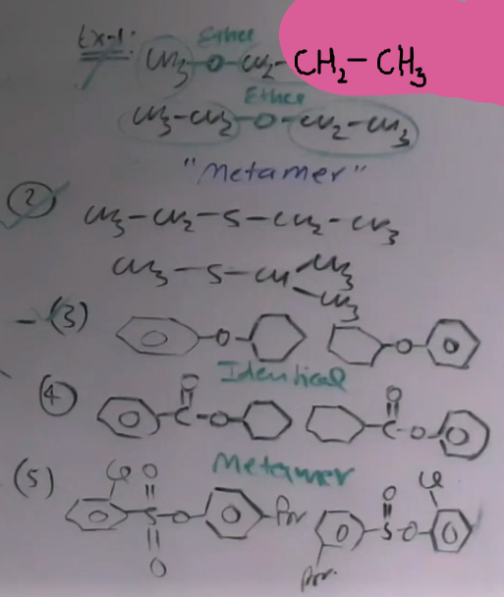
Example: Diethyl ether (Ethyl-O-Ethyl) and Methyl propyl ether (Methyl-O-Propyl) are metamers because the alkyl groups around the oxygen are different.
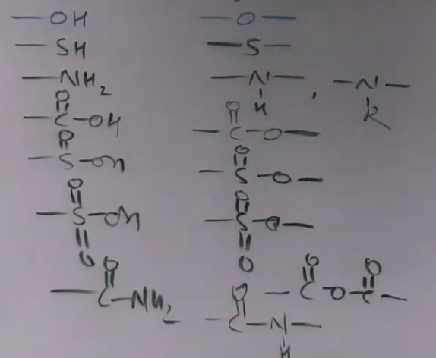
INTUITION AND CONCEPTUAL UNDERSTANDING

CORE THEORY: TAUTOMERISM

DEFINITION:
A special type of functional isomerism where two structures (tautomers) exist in dynamic equilibrium due to the oscillation of a monovalent atom (usually Hydrogen) between two polyvalent atoms within the molecule.

THE FRANKLAND AND DUPPA MYSTERY (STORY OF TAUTOMERISM):
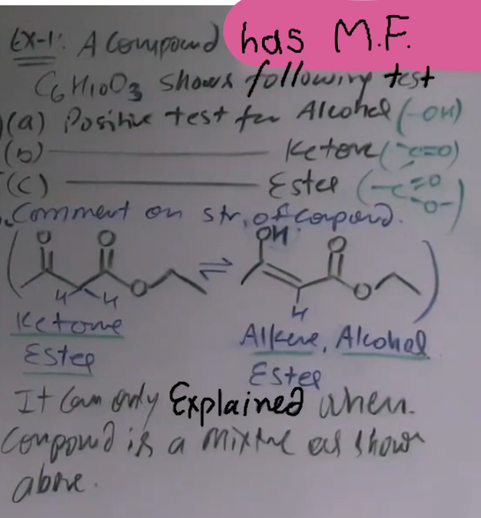
Two chemists, Frankland and Duppa, were studying a compound with the formula C6H10O3. One claimed it was a Keto-Ester, while the other claimed it was an Alcohol-Ester with a double bond. Both were correct because the compound gave positive tests for Alcohol, Ketone, and Ester simultaneously.
Intuition: This is only possible if the compound is not a single structure but a dynamic mixture of two structures in equilibrium. This phenomenon is Tautomerism.
@ photo – tautomerism

TYPES OF TAUTOMERISM:
1. ANIONOTROPY: Oscillation atom is anion. (Note: Not in the IIT-JEE syllabus).
2. CATIONOTROPY: Oscillation atom is cation (usually H+). This is in the syllabus.

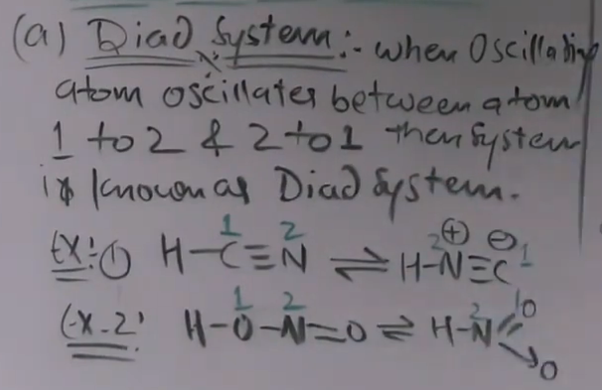
SYSTEMS IN CATIONOTROPY {Types of cationotropy}:
A. DIAD SYSTEM (1,2-SHIFT):
H oscillates between atom 1 and atom 2.
Example: HCN (H-C≡N) is in equilibrium with HNC ( H-N⁺≡C⁻).
Example: Nitrous acid (H-O-N=O) is in equilibrium with HNOO.
@ photo - diad # aur example karne ki jarurat nahi h ye do hi kafi h

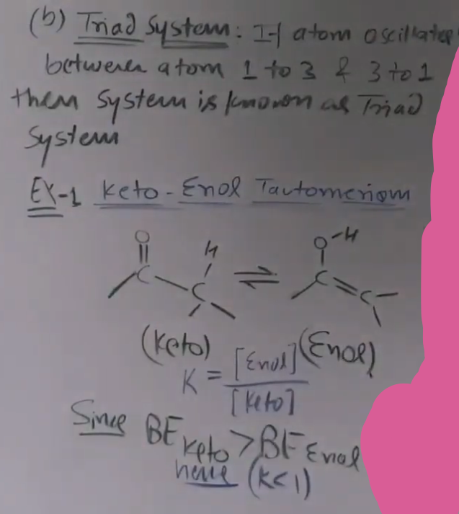
B. TRIAD SYSTEM (1,3-SHIFT):
H oscillates between atom 1 and atom 3.
Example: Keto-Enol Tautomerism.
H moves from Alpha-Carbon (Atom 1) to Oxygen (Atom 3) through a Pi-bond system (Atom 2).
@ photo – triad

EQUILIBRIUM CONSTANT (Keq):
Keq = [Enol Concentration] / [Keto Concentration].

STABILITY DETERMINATION:
Stabilities of Keto and Enol are determined by Bond Energy Data (adding all bond energies in the molecule).
- Simple Systems: Keto > Enol.
- Reason: The bond energy sum of the Keto form (especially the C=O bond) is generally higher than the Enol form.
- Result: For simple ketones (like Acetone), Keq is much less than 1.

FACTORS THAT INCREASE ENOL STABILITY (ENOL > KETO): # Imp.
1. AROMATICITY: If the Enol form is aromatic (e.g., Phenol), it will be 100% stable compared to the non-aromatic keto form.
2. EXTENDED CONJUGATION: More resonance in the enol form increases its percentage.
3. INTRAMOLECULAR H-BONDING:
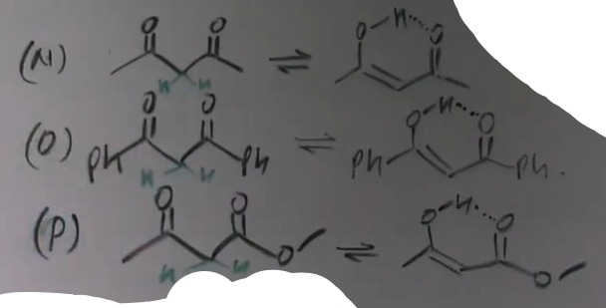
Formation of 5 or 6-membered rings (Chelation) stabilizes the enol, intramolecular H-bonding.
@ photo - tautomerism qs1

# manlo do teen Keto diye ha aur pucha h kiske jyada enol banenge tho jo upper ke in conditions ko follow karega vo jyada percentage m banega.

Bond Energy of Enol would dominate over Bond Energy of Keto in the following cases(i.e. %Enol > %Keto in equillibrium):- #Imp.
a) If Enol is Aromatic.
b) If Keto is cyclic 1,2 di keto.
c) If Keto is 1,3 dicarboxyl (either aldehyde or ketone).
## These are examples of triad system
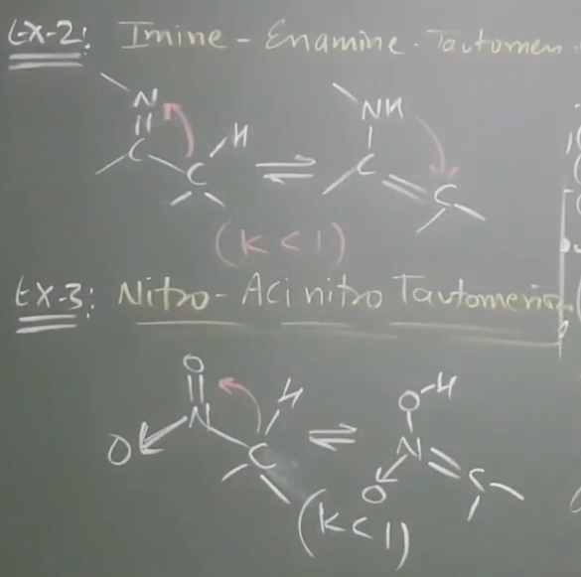
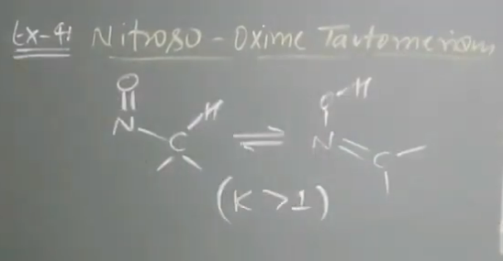
# Ex:2 m Imine form dominates over Enamine form, K<1.
# Ex:3 m Nitro form dominates over Aci nitro form, K<1.
# Ex:4 m Oxime form dominates over Nitroso form, K>1.
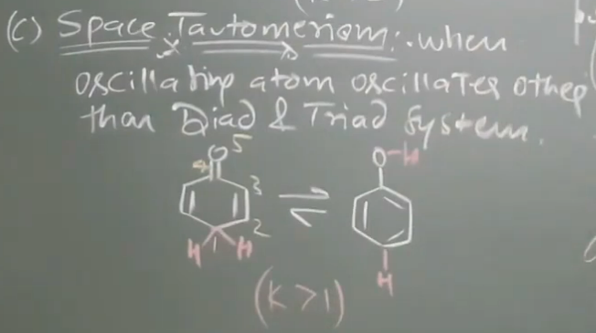
C. SPACE TAUTOMERISM:
When oscillating atom oscillates other than Diad & Triad system.
@ photo - space tautomerism.png # isme Enol dominates over Keto, K>1, Enol is aromatic

CONCEPT CONNECTIONS

- GOC LINK: Tautomerism is essentially an acid-base reaction within the molecule. The Alpha-Hydrogen must be acidic {Alpha-Hydrogen sp3 hona chahiye toh hi hydrogen de payege agar sp3 nahi h toh Beta, agar vo bhi sp3 nahi h toh Gamma ko dekhenge}.
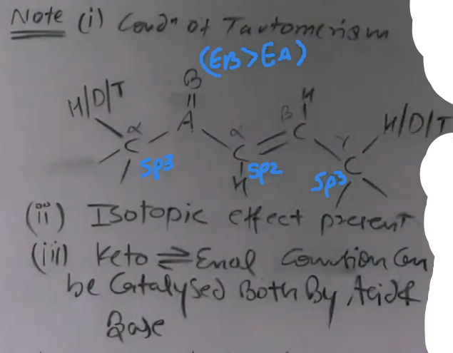
Sabse acidic carbon ya hydrogen nikalne k liye us H ko nikalenge aur agar resulting cation stable hoga toh vo H acidic hoga.
- ISOTOPIC EFFECT: C-H bonds are weaker than C-D bonds. Therefore, H-oscillation is faster than D-oscillation (Rate of H > Rate of D).
- CATALYSIS: Tautomerism is a spontaneous process but can be accelerated by adding an external Acid or Base catalyst.
@ photo - tautomerism note

PROBLEM-SOLVING FRAMEWORK

QUESTION TYPE | IDENTIFICATION CLUE | APPROACH / STRATEGY
CI vs PI | Same MF | Check parent chain length. If length is different, it is CI.
Metamerism | Polyvalent group | Check alkyl groups on both sides. If they differ, it is M.
Identify Tautomer | C=O group + Alpha-H | Check if Alpha-C is sp3 and has an H atom.
Space Tautomerism | sp2 Alpha-Carbon | Check the Gamma-carbon (1,5-position) for sp3 C and H.
Enol Percentage | Aromaticity/H-bond | If Enol is aromatic, Enol > Keto. If simple, Keto > Enol.

EXAMPLES AND APPLICATIONS

EXAMPLE 1: HCN AND HNC
System: Dyad (1,2-shift).
Key Idea: H moves from C to N. Both exist in equilibrium.

EXAMPLE 2: ACETONE (CH3-CO-CH3)
System: Triad (1,3-shift).
Key Idea: H moves from CH3 to Oxygen. Keto is much more stable than Enol.

EXAMPLE 3: NITRO-ACI TAUTOMERISM
System: CH3-NO2 (Nitro) vs CH2=NO2H (Aci-form).
Key Idea: Nitro group can also show tautomerism similar to carbonyls.

JEE ADVANCED INSIGHTS
1. BREDT'S RULE: Tautomerism cannot occur if it requires forming a double bond at the bridgehead of a small bicyclic system, as sp2 hybridization cannot be accommodated there.
4. PARA-POSITION ACIDITY: In extended conjugated systems, Hydrogens even at the 5th position (Gamma) are acidic enough to participate in tautomerism.

COMMON MISTAKES AND TRAPS
MISTAKE | WHY STUDENTS MAKE IT | CORRECT APPROACH
Calling Monovalent Metamers | Confusion with PI | Metamerism is ONLY for polyvalent groups (-O-, -S-, -NH-).
Tautomerism at sp2 Carbon | Ignoring hybridization | Alpha-carbon MUST be sp3 for standard triad tautomerism.
Missing Identical Compounds | Poor numbering | Always name the compound. If names are identical, they are not isomers.
Treating Amines as PI | Moving the N atom | 1, 2, and 3 degree amines are Functional Isomers (FI).

HIGH-YIELD REVISION SHEET

MUST REMEMBER:
- Priority: RT P F M C P (Ring-Chain > Tautomer > Functional > Metamer > Chain > Position).
- Amines: 1, 2, 3 degree amines are FI.
- Metamers: Requires polyvalent group; distribution of alkyl groups must differ.
- Tautomerism Condition: Polar multiple bond + Alpha-H on sp3 carbon.

KEY STABILITY OBSERVATIONS:
- Simple Keto > Simple Enol.
- Aromatic Enol > Keto.
- Enol with 6-membered H-bonding (like Acetylacetone) has high enol content.

LAST-MINUTE REVISION POINTS:
- Dyad system = 1,2-shift (HCN).
- Triad system = 1,3-shift (Keto-Enol).
- Space Tautomerism = 1,5-shift (occurs when alpha is sp2 but gamma is sp3 with H).
- Bridgehead carbons in small rings cannot form double bonds (Bredt's Rule).
- Catalyst: Acid or Base only changes the speed, not the final equilibrium position.

------------------------------------------------------------------------------------------------------------------------------------
STRUCTURAL ISOMERISM AND TAUTOMERISM - LECTURE 03 NOTES

CORE THEORY: TAUTOMERISM CONDITIONS AND ENOL STABILITY

Tautomerism is a dynamic equilibrium where a compound oscillates between two forms, typically the Keto and Enol forms. For a compound to exhibit tautomerism, it must meet specific structural requirements.

1. BASIC CONDITIONS
- The alpha-carbon must be sp3 hybridized.
- There must be at least one acidic hydrogen (H), deuterium (D), or tritium (T) present on that alpha-carbon.
- If these conditions are met, the molecule can undergo tautomerism.

2. ENOL VS KETO DOMINANCE
In simple systems, the Keto form is more stable due to bond energy data (C=O is stronger). However, the Enol form can dominate (Enol %age > Keto %age) in three specific cases:
- Aromaticity: If the Enol form is aromatic, it will be significantly more stable (e.g., Phenol).
- Cyclic 1,2-Diketones: When carbonyls are at positions 1 and 2 in a ring.
- 1,3-Dicarbonyls: Also known as active methylene compounds, where carbonyls are at positions 1 and 3.

@ photo - tautomerism qs
#e) se lekar j) tak ya toh sp3 carbon hi nahi tha ya uspe hydrogen nahi tha g) m tautomerism nahi hoga kyunki Beta carbon m toh hydrogen h par Alpha carbon sp3 h, usme p-orbital nahi h isliye tautomerism nahi hoga. Aur a) se lekar d) tak sabme Keto jyada stable hoga.

@ photo - tautomerism qs2
# p) m Keto > Enol hoga kyunki conditions m likhaya that ki agar 1, 3 position m ketone ya aldehyde ho yaha ek ketone aur dusra ester h.

@ photo - tautomerism qs3
# R) wale m jo beech wala h usme O-O k beech m repulsion hoga aur vo ghum ke left wala ban jayega jisme repulsion bhi kam h dipole moment bhi 0 h phir ye simple chain wala case ban jayega aur Keto > Enol hoga.
# S) m bhi same h case h par ab ye rotate nahi kar sakta, isliye usme repulsion jyada h toh Enol > Keto hoga ye note m bhi likha h.

3. BREDT'S RULE IN TAUTOMERISM
Tautomerism cannot occur at the bridgehead position of a small bicyclic system if it requires the formation of a double bond at that bridgehead. This is because the bridgehead carbon cannot achieve the planarity required for sp2 hybridization, making the resulting Enol form highly unstable.

INTUITION AND CONCEPTUAL UNDERSTANDING

ACTIVE METHYLENE STABILITY:
In 1,3-dicarbonyl systems (like acetylacetone), the Enol form is stabilized by a six-membered ring formed through intramolecular hydrogen bonding, also called chelation. This makes the Enol content very high (e.g., around 76 percent in some 1,3-diketones).

SOLVENT AND TEMPERATURE INTUITION:
- Temperature: Think of the Enol form as being "held together" by a delicate hydrogen bond. Increasing temperature provides enough kinetic energy to break this bond, causing the Enol percentage to decrease.
- Solvent: Polar solvents like water "love" the polar Keto form (C=O) and surround it (solvation), making it more stable. Non-polar solvents allow the Enol form to maintain its internal hydrogen bonds.

FORMULA AND CONDITION SHEET

| CASE | CONDITION | RESULT |
| :--- | :--- | :--- |
| Simple Ketone | No extra stabilization | Keto > Enol |
| Phenol | Aromaticity in Enol | Enol is almost 100 percent |
| 1,3-Diketone | Intramolecular H-bonding | High Enol (e.g., 76 percent) |
| Bridgehead H | Bicyclic system | No Tautomerism (Bredt's Rule) |

DEUTERIUM EXCHANGE (KINETIC ISOTOPIC EFFECT)
When a compound that can tautomerize is placed in heavy water (D2O) with a base (OD-) for a long time, all its acidic alpha-hydrogens are replaced by deuterium.
- Process: Base removes H+ to form a carbanion -> Carbanion picks up D+ from D2O -> Repeated cycles replace all H with D.
- Final Product: The most stable form will be the one where all exchangeable hydrogens are replaced by D because the C-D bond is stronger than the C-H bond.
@ photo - kinetic isotopic exchange.png # carbonyl (-C=O) ke respect m acidic H dhundo unhe hatake D laga do.
@ photo - kinetic isotopic exchange1 # 9) m jab Gamma carbon p negative aayega toh resonance ki wajah se vo Alpha carbon p bhi aayega toh Alpha p bhi D laga par kaise bhi Beta p nahi aayega isliye uspe D nahi aaya.

CONCEPT CONNECTIONS

- ACIDIC STRENGTH: The alpha-hydrogens between two carbonyl groups (active methylene) are highly acidic, which is why they form stable Enols.
- RESONANCE: In systems where a carbanion can delocalize to an oxygen (like gamma-H in conjugated systems), tautomerism can occur even further away from the carbonyl. This is sometimes called "Space Tautomerism."
- KINETICS: C-H bonds break faster than C-D bonds, meaning the rate of tautomerism is faster for hydrogen than for deuterium.

PROBLEM-SOLVING FRAMEWORK: D-EXCHANGE

| STEP | ACTION | COMMON MISTAKE |
| :--- | :--- | :--- |
| 1 | Identify all Alpha-carbons | Missing carbons on one side of C=O |
| 2 | Check if Alpha-C is sp3 | Attempting exchange at sp2 carbons |
| 3 | Count Alpha-H atoms | Forgetting H atoms at bridgeheads |
| 4 | Look for Conjugation | Missing acidic H at Gamma positions |
| 5 | Replace with D | Miscounting the total number of D atoms |

EXAMPLES AND APPLICATIONS

EXAMPLE 1: ACETONE (CH3-CO-CH3)
Placed in D2O/OD-. It has two alpha-carbons with 3 hydrogens each. Total exchangeable H = 6. Final product has 6 Deuteriums.

EXAMPLE 2: NON-CONJUGATED TO CONJUGATED TRANSITION
A non-conjugated alkene system may tautomerize into a more stable conjugated configuration. If both give the same Enol, they will eventually produce the same D-exchange product.
@ photo - kinetic isotopic exchange2 # 16 m left aur right wale ka enol form same h toh vo more stable form m tautomerize ho jate h jaise yaha right wale jyada stable h resonance ki wajah se.

JEE ADVANCED INSIGHTS: FACTORS AFFECTING ENOL PERCENTAGE

1. SIZE OF R-GROUPS (R1 AND R2)
- Increasing size of Terminal R1: Pushes the terminal oxygens closer together, strengthening the intramolecular H-bond. This increases the Enol percentage.
- Increasing size of Middle R2 (on the active methylene carbon): Forces the molecule to rotate to avoid steric repulsion. This rotation breaks the planarity needed for the Enol's resonance and H-bonding. This decreases the Enol percentage.
@ photo - r1 r2.png

2. TEMPERATURE EFFECT
Increasing temperature decreases Enol percentage because it breaks the stabilizing intramolecular hydrogen bonds.

3. SOLVENT EFFECT
- Polar Protic Solvents (Water): Favor the Keto form because the C=O bond is more polar and undergoes better solvation.
- Non-Polar Solvents (Hexane/Gas Phase): Favor the Enol form because there is no competing solvation, allowing internal H-bonding to dominate.
@ photo - polarity

COMMON MISTAKES AND TRAPS

| MISTAKE | WHY IT HAPPENS | CORRECT THINKING |
| :--- | :--- | :--- |
| Exchanging H at Bridgehead | Ignoring ring strain | Bredt's Rule: Double bonds can't form at bridgeheads |
| Missing Gamma-H Exchange | Only looking at Alpha-C | If conjugated, Gamma-H is acidic and will exchange |
| Assuming 1,3-Diketone is 100% Enol | Overestimating H-bond | It is high (76%) but not always 100% unless aromatic |
| Ignoring Hybridization | Seeing H on any C near C=O | Carbon MUST be sp3 to participate in triad shift |

HIGH-YIELD REVISION SHEET

MUST REMEMBER:
- Conditions: sp3 Alpha-C + at least 1 Alpha-H/D/T.
- Enol > Keto: Aromaticity, Cyclic 1,2-diketone, 1,3-diketone (chelation).
- Bredt's Rule: No tautomerism at bridgeheads of small rings.
- D-Exchange: All acidic hydrogens (alpha and conjugated gamma) are replaced by D in D2O/OD-.
- Solvent: Water (Polar) favors Keto; Hexane (Non-polar) favors Enol.

FREQUENTLY TESTED PATTERNS:
- Counting the number of Deuteriums after long-term exchange.
- Comparing Enol content of different 1,3-dicarbonyls based on R-group size.
- Identifying which molecules among a list can undergo tautomerism.

LAST-MINUTE REVISION POINTS:
- C-D bond is stronger than C-H bond.
- Increasing temperature breaks H-bonds and reduces Enol %.
- Terminal group size increase = Enol increase.
- Middle group size increase = Enol decrease.

